KL Wolley
12/02/2018

Week 13
Recursion
Pg. 168 # 13
- a_{n} = 8a_{n-1} – 16a_{n-2}
  - a_{n} = 0
Substituting 0 for all a_{n} yields:
0 = 8 * 0 – 16 * 0
0 = 0
Because both sides are equal, a_{n} = 0 is a solution of the recurrence relation.

  - a_{n} = 1
Substituting 1 for all a_{n} yields:
1 = 8 * 1 – 16 * 1
1 != -8
Both sides are NOT equal, a_{n} = 1 is NOT a solution.

  - a_{n} = 2^{n}
Substituting 2^{n} for all a_{n} yields:
2^{n} = 8 * 2^{n-1} – 16 * 2^{n-2}
Simplifying the right side of the equation by consolidating exponents:
2^{n} = (8 * * 2 – 16 )2^{n-2}
2^{n} = (16 – 16)2^{n-2}
2^{n} = (0)2^{n-2}
2^{n} != 0
Both sides are NOT equal, a_{n} = 2^{n} is NOT a solution.

  - a_{n} = 4^{n}
Substituting 4^{n} for all a_{n} yields:
4^{n} = 8 * 4^{n-1} – 16 * 4^{n-2}
Simplifying the right side of the equation by consolidating exponents:
4^{n} = (8 * * 4 – 16 )4^{n-2}
4^{n} = (32 – 16)4^{n-2}
4^{n} = (16)4^{n-2}
4^{n} = (4²)4^{n-2}
4^{n} = 4^{n-2+2}
4^{n} = 4^{n}
Both sides are equal, a_{n} = 4^{n} is a solution.

- Tower of Hanoi puzzle.
Inductive proof of minimum number of moves required to transfer disks to new peg.
Let n be the number of disks on peg 1.
Let m be the number of moves it takes to transfer the disks.
 | m_{n} = 2^{n} – 1
Base case | n = 1
 | m(1) = 2¹ -1
 | m(1) = 1
Inductive Hypothesis (IH) | assume that m(k) = 2k – 1 for k >= 0
Solve | Prove m_{k} = 2^{k} -1 = 2m_{k-1}+ 1 is true for k+1
 | 2^{k+1} -1 | = 2(m_{k-1+1}) + 1
 |  | = 2(m_{k}) + 1
 |  | = 2 (2^{k} – 1) + 1
 |  | = 2^{k+1} – 2 + 1
 |  | = 2^{k+1} - 1

- Recursive gcd

Recursive gcd | Euclidean
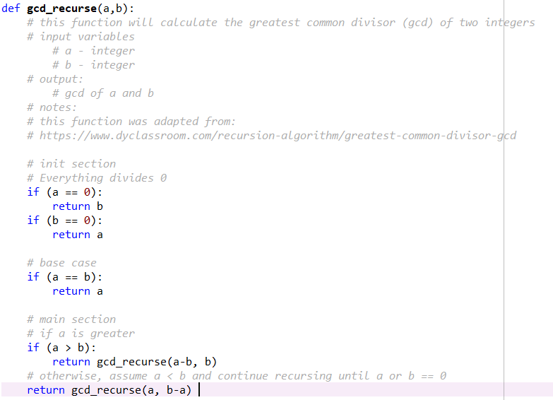 | 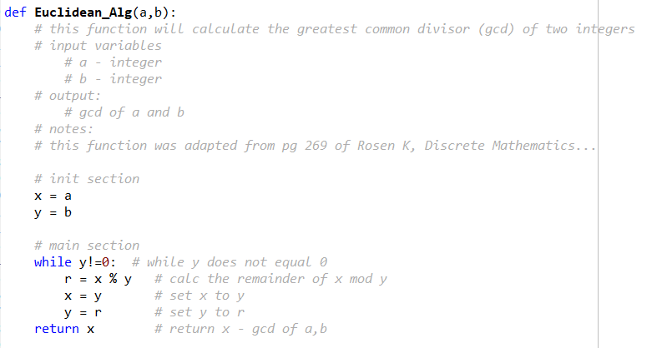

Output by each function with the input values for A and B is as follows:
Input Variables |  | Output
A | B | Gcd_recurse | Euclidean_Alg
24 | 36 | 12 | 12
17 | 22 | 1 | 1
91 | 287 | 7 | 7

Both cases above implement an initialization section of code. This section is used to test if either of the input values is == 0 (which, for the recursive method, is the termination point). The test for 0 in the Euclidean_Alg is that the while loop will not be entered if one of the values is equal to 0. These codes are very similar however the method by which the gcd is calculated is with through recursion or a while loop. Recursive methods may be more prone to errors (segmentation faults) if a termination code is not implemented correctly. In this example the termination code is if either a or b is equal to 0. Assuming both functions are programmed correctly they may by equally effective in finding the gcd of two numbers.

- The Fibonacci sequence

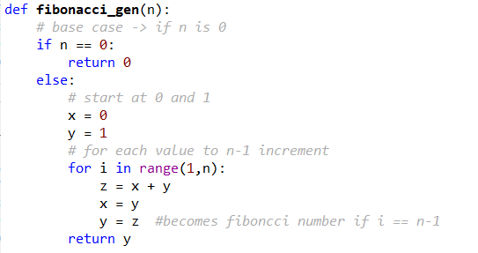

Now, modify your code to calculate the ratio of the nth fib number and the (n-1)th fib number.
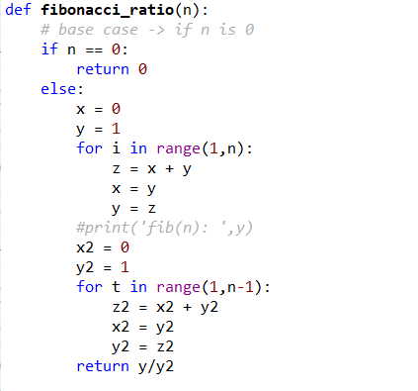 | Term Value  1 1.0000000000  2 1.0000000000  3 2.0000000000  4 1.5000000000  5 1.6666666667  6 1.6000000000  7 1.6250000000  8 1.6153846154  9 1.6190476190  10 1.6176470588  11 1.6181818182  12 1.6179775281  13 1.6180555556  14 1.6180257511  15 1.6180371353  16 1.6180327869  17 1.6180344478  18 1.6180338134  19 1.6180340557  20 1.6180339632

The resulting ratio approaches the golden ratio!

The change in start values for f(0) and f(1) and the resulting sequence is shown in the table below:
 | f(0) = 5  f(1) = 17 | f(0) = -5  f(1) = -17 | f(0) = .01  f(1) = 1000
1 | 1.00000 | 1.00000 | 1.00000
2 | 1.29412 | 1.29412 | 1.00001
3 | 1.77273 | 1.77273 | 1.99999
4 | 1.56410 | 1.56410 | 1.50000
5 | 1.63934 | 1.63934 | 1.66667
6 | 1.61000 | 1.61000 | 1.60000
7 | 1.62112 | 1.62112 | 1.62500
8 | 1.61686 | 1.61686 | 1.61538
9 | 1.61848 | 1.61848 | 1.61905
10 | 1.61786 | 1.61786 | 1.61765
11 | 1.61810 | 1.61810 | 1.61818
12 | 1.61801 | 1.61801 | 1.61798
13 | 1.61804 | 1.61804 | 1.61806
14 | 1.61803 | 1.61803 | 1.61803
15 | 1.61804 | 1.61804 | 1.61804
16 | 1.61803 | 1.61803 | 1.61803
17 | 1.61803 | 1.61803 | 1.61803
18 | 1.61803 | 1.61803 | 1.61803
19 | 1.61803 | 1.61803 | 1.61803

In all cases, the sequence again approaches the Golden Ratio! Initially this is surprising however, in the end, it makes sense that the same would occur for any two start values however the number of iterations required to reach the Golden Ratio will vary.

